LAB-2:

(PROGRAMMING CONCEPTS 2)

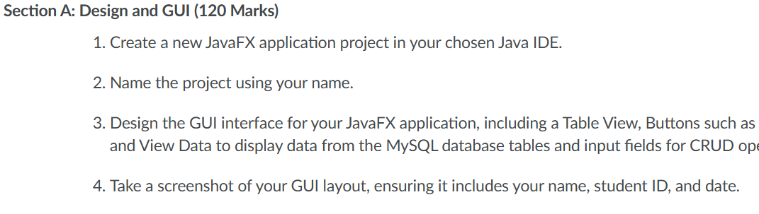

CREATING DATABSE USING CRUD_db NAME:

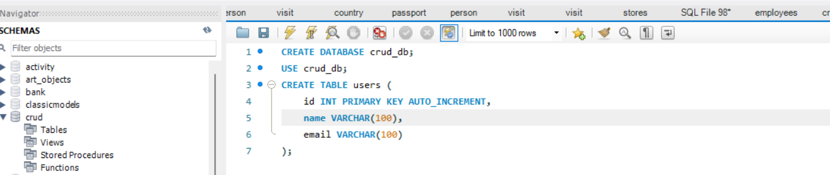

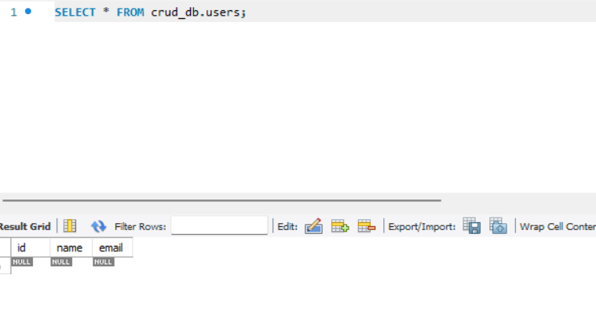

**Section B: Database Connection (180 Marks)**

1. **Implement the database connection code in your JavaFX application.**
2. **Ensure it includes the necessary database URL, username, and password.**
3. **Take a screenshot of the code where you establish the database connection.**

**Section C: Data Models and ORM (120 Marks)**

* **Create Java classes that represent the structure of your database tables.**
* **These classes will be used to model the data you retrieve from and insert into the database.**
* **Use Object-Relational Mapping (ORM) techniques to simplify database interactions.**

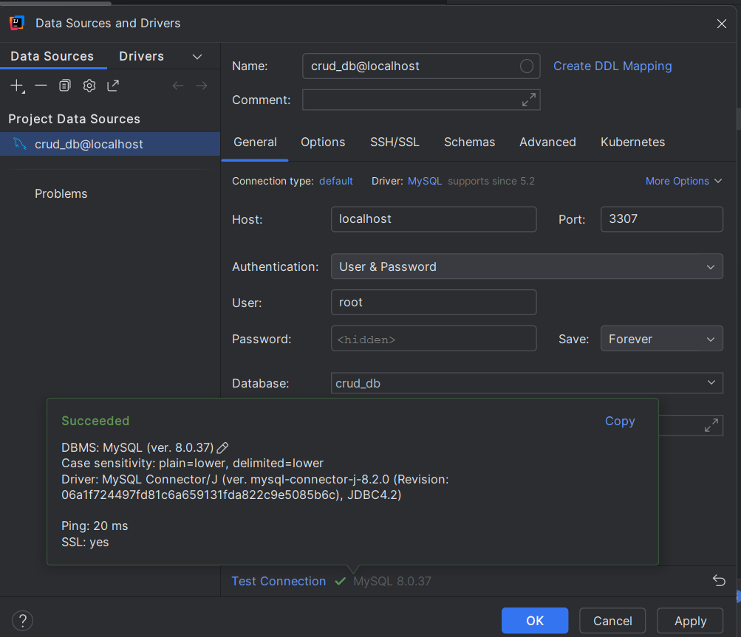

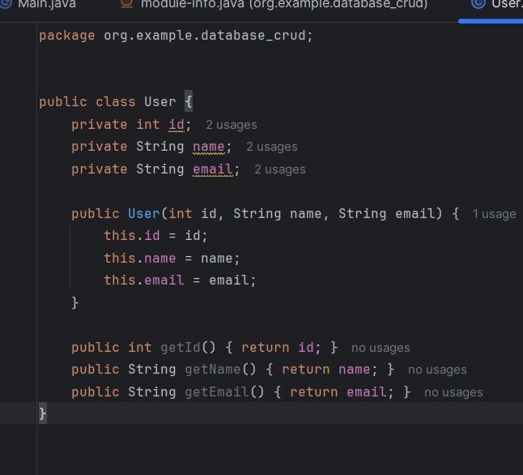

**Section D: Open JDBC Jar (120 Marks)**

1. **Download and include the appropriate JDBC driver (for example, MySQL Connector/J) in your project.**
2. **Ensure that your project's build path includes the JDBC driver JAR file.**

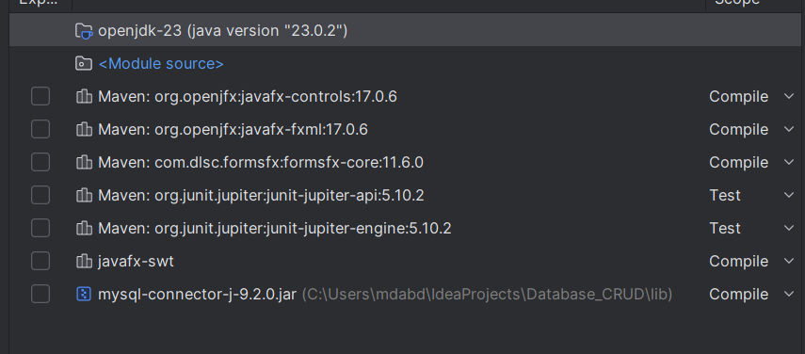**Section E: Load Data in Table View (120 Marks)**

1. **Write code to retrieve data from the MySQL database tables and load it into the Table View component.**
2. **Implement an event handler to trigger this action on button click.**

**Section F: Insert Data into Database (120 Marks)**

1. **Write code to insert data into the database when a button is clicked.**
2. **Ensure that the input fields on the GUI are used to gather data for insertion.**

**Section G: Update Data in Database (120 Marks)**

1. **Write code to update existing data in the database when a button is clicked.**
2. **Allow the user to provide an ID to identify the data to update.**

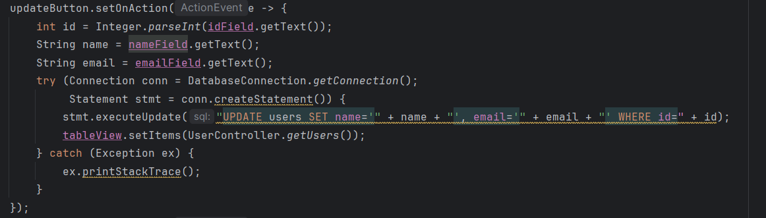

**  
ABDUL WAS REPLACE BY NAVEEN**

**Section H: Delete Data from Database (120 Marks)**

1. **Write code to delete data from the database when a button is clicked.**
2. **Provide the option for the user to specify an ID for data deletion.**

**Naveen was removed from table**

**SCREEN SHORT OF WORKBENCH**

**Section I: GitHub and Documentation (180 Marks)**

1. **Upload your JavaFX project to a GitHub repository.**
2. **Create a DOCX or PDF document including:**
3. **Screenshots of your GUI layout with your name, student ID, and date.**
4. **Screenshots of your database table structures and sample data.**
5. **Screenshots of relevant portions of your code.**
6. **A link to your GitHub repository.**

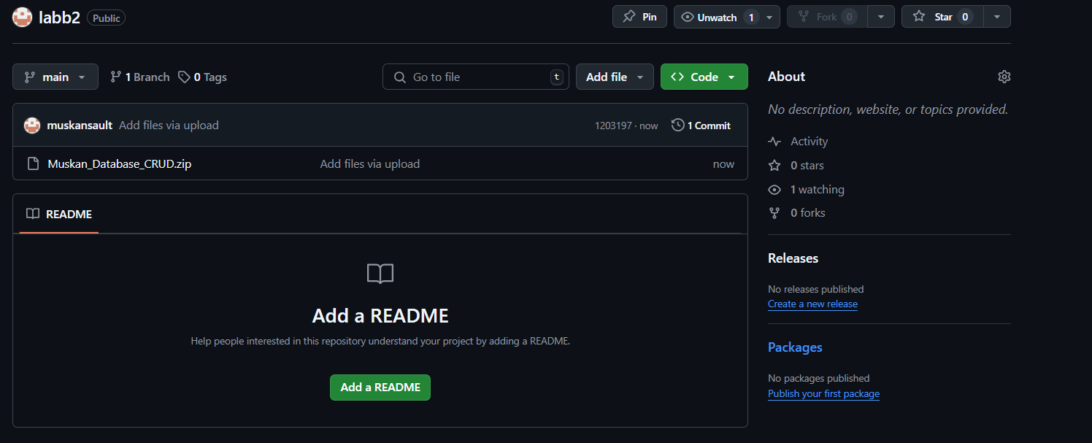

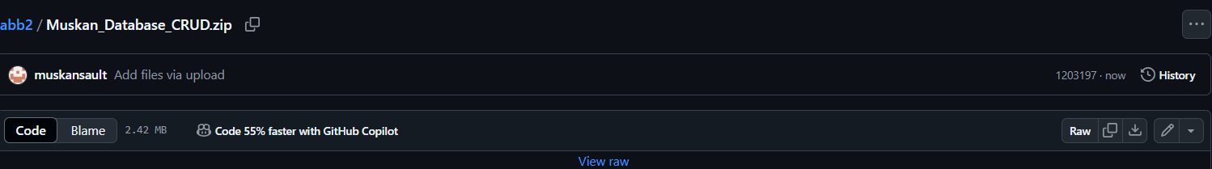

https://github.com/muskansault/labb2.gits